**Novel Configurable Atmospheric Instrumentation**

Sam Yui Sum Lo

A transfer thesis submitted for the degree of Doctor of Philosophy

University of Bath

Department of Electronic and Electrical Engineering

February 2017

**COPYRIGHT**

Attention is drawn to the fact that copyright of this thesis/portfolio rests with the author and copyright of any previously published materials included may rest with third parties. A copy of this thesis/portfolio has been supplied on condition that anyone who consults it understands that they must not copy it or use material from it except as permitted by law or with the consent of the author or other copyright owners, as applicable.

This thesis/portfolio may be made available for consultation

within the University Library and may be photocopied

or lent to other libraries for the purposes of consultation

with effect from……………….*(date)*

Signed on behalf of the Faculty/School of...................................

Table of Contents

1. Abstract 3

2. Introduction 4

3. Background Literature Review 5

3.1. Atmospheric Science 5

3.2. Aerosols Properties 6

3.2.2. Dust 9

3.2.3. Black Carbon 11

3.2.4. Ammonium Nitrate 12

3.3. Absorption Spectrum 13

3.3.1. UV Spectrum 14

3.3.2. Visible Spectrum 14

3.3.3. Infrared Spectrum 14

3.4. Beer-Lambert Law 15

3.5. Langley Extrapolation 16

3.6. Perez-Dumortier Model 17

4. Feasibility analysis of sun photometers 19

4.1. GLOBE Sun photometer 19

4.2. SkyClarity Device 20

4.3. Sun and Sky Monitoring Station by Radioshack 20

4.4. Sun and Sky Monitoring Station by University of Southampton 21

4.5. Microtops 21

5. Sun photometer Prototype Design 24

5.1. Requirements for designing a sun photometer prototype 24

5.2. Research challenges for designing a sun photometer 25

5.2.1. Field work locations 25

5.2.2. LED characteristics 25

5.3. Sun photometer prototyping methods 26

5.4. Basic tests 27

5.4.1. Spectral Measurements 27

5.5. Results and discussion – Optical Filters 28

6. Future Research Work 31

6.1. Plan for the rest of PhD 31

6.1.1. System integration 31

6.1.2. Journal Publications 32

6.1.3. Validate against GPS Water vapour 33

7. References 35

8. Appendix 1 - Theoretical Prediction of solar elevation angle 38

8.1. Solar Elevation Angle Positioning 38

8.2. Theoretical Prediction of clearness indexes 38

# 1. Abstract

# The Sun radiates light to the earth’s surface through the atmosphere including the troposphere. However, the aerosols and water vapour scatter light along its path. A sun photometer is an instrument, which can detect the aerosol and water vapour content through mathematical modelling techniques. The objectives of this research are to monitor air pollution and aerosol distribution in the atmosphere. In particular I will investigate aerosols, which are harmful to human health and climate, and enhance the novelty of atmospheric instruments. The newly developed sun photometer will be designed, built and demonstrated in this research. There are plans for two journal articles. The titles of the papers are ‘Calibration of sun photometer over the UK’ and ‘Validation of water vapour measurements’. The instrument will be calibrated to the local atmosphere by measuring atmospheric aerosol and water vapour over a period of a year. The location is Bath University. The calibration will take into account the season and elevation of the sun (hence, the path through the atmosphere.) for nominal days throughout the year. The sun photometer will be capable to integrate voltage data with GPS positioning tracking device and calibrate the data by using a combination of the Langley Extrapolation and Perez- Dumortier Model. It is likely that the new sun photometer will be capable of indicating the level of pollution to users, and giving clearer information on atmospheric pollution in the local atmosphere.

# 2. Introduction

Natural and man-made events form different types of aerosols and gases, which then cause atmospheric pollution. This phenomenon is a major concern for human health and climate. Pneumonia, Asthma, nausea, and nephritis[1] [2] [3] [4] are examples of illnesses, that are caused by pollution gases and aerosols in the atmosphere.

The objectives of this research are 1: to monitor air pollution and aerosol distribution in the atmosphere, in particular aerosols [5] which are harmful to human health and climate. and 2: to enhance the novelty of atmospheric instruments. This research also involves investigating novel data communications to connect the remote sensor to the network [6] [7] It also looks into the portability through miniaturisation of the device.[8]

One particular instrument for monitoring pollution is a sun photometer. They have been used to analyse the aerosol distribution in the atmosphere [9] [10] [11] [12]. In this research, a new sun photometer will be developed that is different from previous sun photometers because it is miniaturized and portable. In addition, it will integrate with an HF radio transceiver, or a 4G datalink [13] [14] and hence achieve mobile communications both in and out of regions with mobile phone network coverage. [7]

Chapter 2 gives an introduction to atmospheric science and aerosols. They are important because they can affect the climate and human health. It also gives the theory of wavelength scattering and absorption spectrum, which relates to aerosols optical depth measurements. The Beer-Lambert’s Law, and Langley calibration method are measurement methods to obtain voltage results in the sun photometer. These are also described in Chapter 2.

Chapter 3 contains a review on previous sun photometers. This investigates the configuration, and implementation of building previous sun photometers. This includes the feasibility of using those sun photometers including detection wavelength, applications, as well as their advantages and disadvantages.  It gives ideas of methods to build a feasible sun photometer in this research. The feasibility of the sun photometer in this research is briefly described in Chapter 4.

Chapter 5 described is the methodology of building the sun photometer for this research, including schematic configuration of building a sun photometer prototype, and software implementation with Arduino for data logging experimental data. Chapter 5 also describes the testing of the prototype including optical filter measurements, and board measurements.  The response of the sun photometer prototype is presented as preliminary results for further analysis.

Finally, Chapter 6 gives the challenges of this research and future work on this research.

# 3. Background Literature Review

## 3.1. Atmospheric Layers

The earth’s atmosphere can be divided into 4 layers, which are troposphere, stratosphere, mesosphere and ionosphere. This research focuses on troposphere, where the aerosols and water vapour are distributed [1]. Figure 1 shows that the troposphere is from the ground to 14km from the earth surface. It contains different climates and weathers such as rain and wind currents.

Aerosols are particles, which scatter or absorb optical wavelengths in air. They change their states within the troposphere through chemical reactions with water vapour, oxygen and nitrogen.,and also migrate with the wind current in the atmosphere.

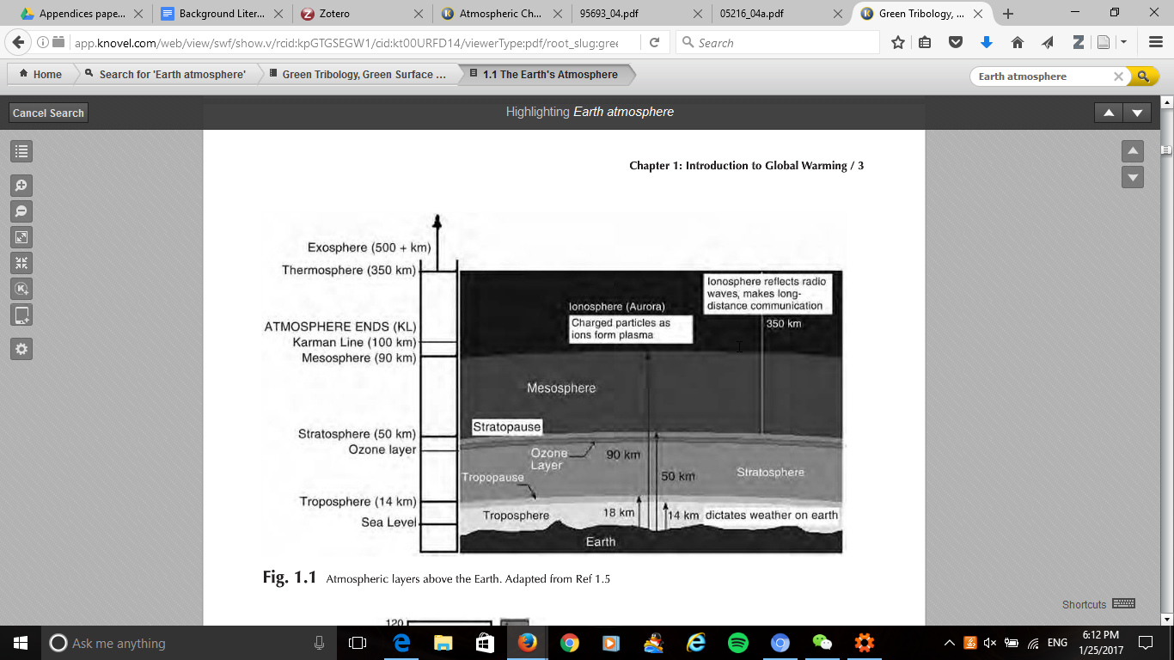

Figure 1 - Atmospheric Layer Diagram [1]

Aerosols can arise naturally from natural events and disasters such as volcanic ash, dust from sandstorm and convection reaction of water driven by solar radiation. They can also come artificially from man-made events such as polluted gases from combustion process [3] [4]. Section 3.2 gives more detail of the properties of aerosols.

## 3.2. Aerosols Properties

This section focuses on aerosols. Aerosols are particles which scatter or absorb optical wavelengths in air. They come from natural and man-made sources such as volcanic activities, dust storms, and fossil fuel combustion. There are various sizes and shapes of aerosols spreading from a range of nanometre to micrometre [2]. Figure 2 shows that various physical and chemical conversion activities form different sizes of aerosols and they change both physical and chemical properties of the aerosols. For example, the physical mechanisms acting on the aerosols such as condensation and coagulation change the aerosols to accumulation mode. They can be removed by rain-wash or sedimentation depending on their sizes. [3].[4]

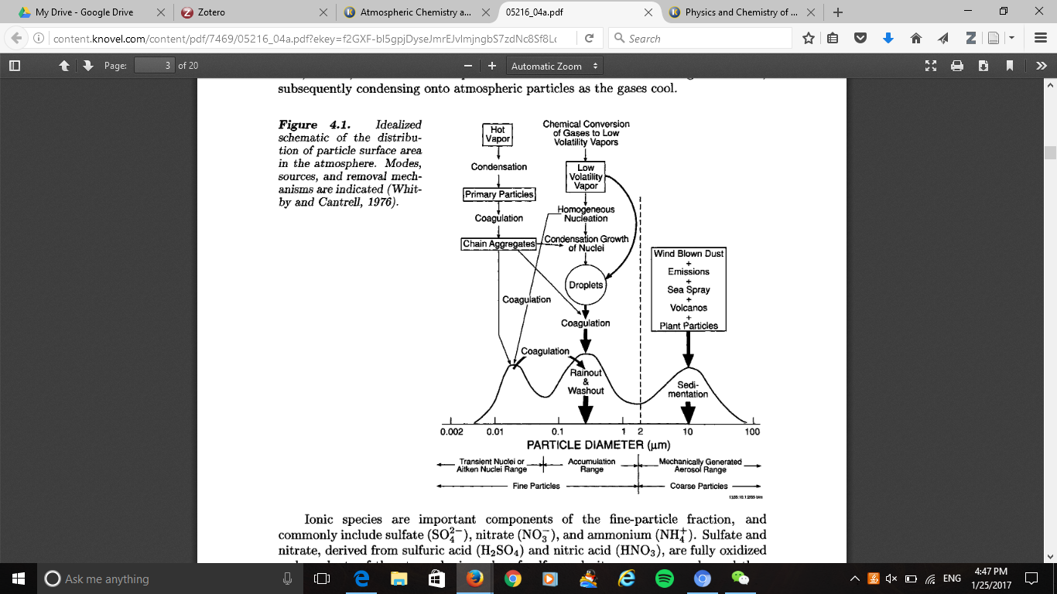

Figure 2- Idealised schematic of the sources and sink of primary and secondary aerosols. [5]

Aerosols have impact on changing the climate by absorbing or scattering optical wavelengths within the absorption spectrum. Sulfate, dust, black carbon and nitrate are major aerosols scattering in the atmosphere.  We will now examine them each in turns in the next few sections.

**3.2.1. Sulfate**

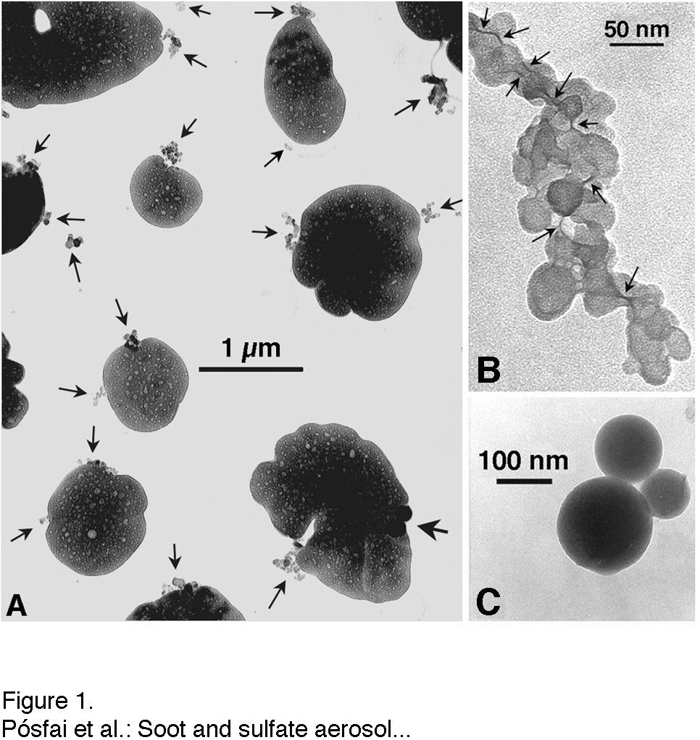

Figure 3- Soot and Sulfate aerosol sizes (A) 1000nm (B) 50nm (C) 100nm [6]

Volcanic activities and man-made pollution such as fossil fuel combustion release sulfur dioxide into the atmosphere. Sulfur dioxide is a harmful aerosol to humans and climate. Figure 3 shows that the sizes of sulfate aerosols are varied from 50nm to 1000nm. The aerosols in are fine particles that can be easily inhaled into the lungs, which causes lung cancer [7] . They also have cooling effect to the climate with their scattering properties. [3] It can scatter and absorb wavelengths in the atmosphere ranged from 370nm to 880nm.[8]

Sulfate aerosols suspend in both the troposphere and stratosphere [3] They are reactive to water vapour and other gases such as nitrogen and chlorine.

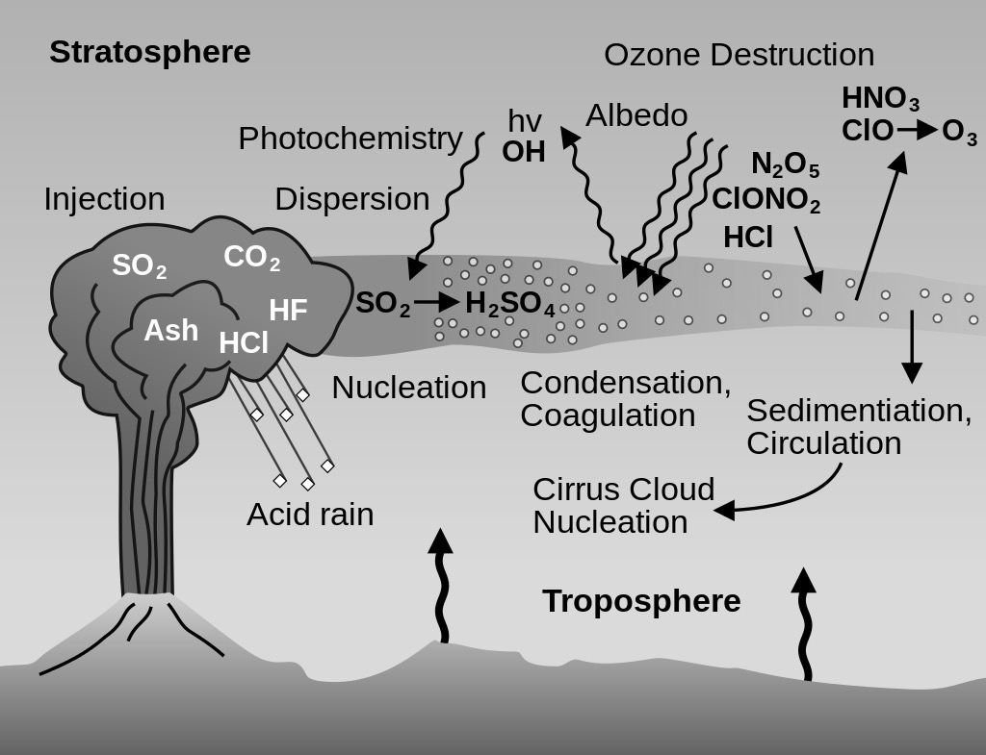

Figure 4 – Sulfate aerosol cycle from volcanic ash [9]

This reaction is between nitrogen and chlorine gases, and it occurs on the surface of sulfate aerosols in the stratosphere. This will cause destruction to the ozone layer in the stratosphere. Sulfate aerosol can react with gases such as hydrochloric acid to form ozone layer, which causes ozone destruction. The level of chemical reaction is depending on the size of sulfate aerosol.

### 3.2.2. Dust

Natural events or man-made events can form dust, which is an aerosol harmful to humans and climate. Dust mainly comes from deserts like Sahara desert but it can also come from man-made disasters or building demolitions[7] They can scatter and absorb wavelengths within the visible range. The concentration of dust can affect our visibility, and causing respiratory diseases such as asthma[2]. Coarse dust particles and fine dust particles are two categories of dust particles, which are depending on its sizes. Coarse dust particles have sizes from 2.5µm to 10µm, and fine dust particles have sizes with less than 2.5µm. [10].

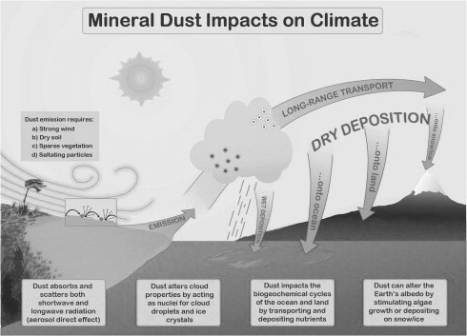

Figure 5 – Interactions between dust and the atmosphere [11]

They can also cause modifications on other atmospheric gases and pollutants such as nitrogen dioxide, hydrogen, and ozone. Water vapour molecules, and hydrogen ions attach onto the peripheral round of the dust particle surface. Figure 5 shows that the dust can travel with wind current and react with water vapour to form aerosols.

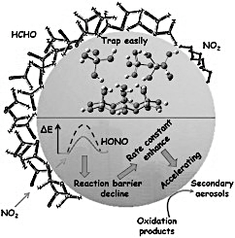

Figure 6 – Chemical reaction of dust with nitrogen dioxide [11]

Figure 6 shows that dust can react with nitrogen dioxide, and the reactive product undergoes reactions to change the properties of the dust particle. Dust can also spread from the source region to remote locations through wind currents. [12]. The intensity of the reaction between nitrogen oxide and dust is depending on the sizes of dust particles. This means that more nitrogen oxide will react on the surface of the dust particles when the size increases.[13].

### 3.2.3. Black Carbon

Carbon based gases form black carbon, which can be carbon monoxide and carbon dioxide. The size of black carbon varies from 0.1µm to 10µm. It can be suspended as aerosols in the atmosphere for at least 40 hours. [1] [2] Figure 7 shows the distribution of black carbon aerosols in the world in February 2009. It shows that the concentration of black carbon is depending on natural and man-made events like wildfires, fossil fuel combustion and gas emission from vehicles [14].

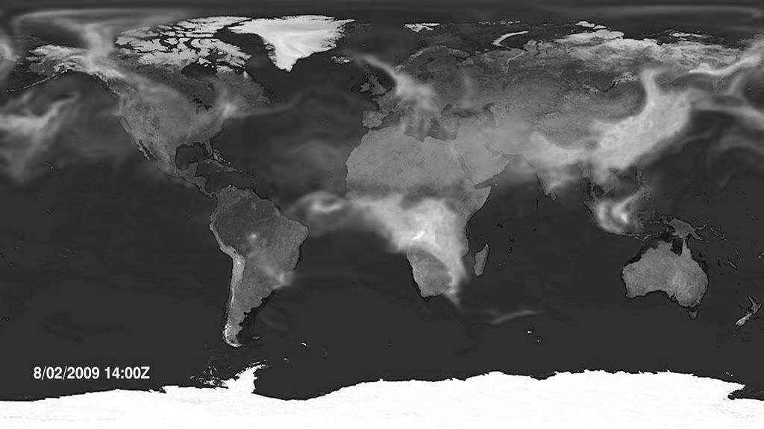

**Figure 7 - Global Black Carbon Aerosol Distribution in February 2009 [2]**

They are harmful to humans’ health, which causes respiratory diseases. [3] Black carbon, which have aerosols sizes larger than 4µm, and smaller than 0.002µm, can deposit into human’s mouth and throat, while those which are between 0.002 µm to 0.2 µm can deposit into the alveolar region of human’s lungs. [4] [5]. They also can cause modifications on other atmospheric gases and pollutants such as nitrogen dioxide, hydrogen, and ozone. Water vapour molecules, and hydrogen ions attach at the peripheral round of the dust particle surface [6]. Figure 5 shows that the dust can travel with wind current and react with water vapour to form aerosols.

Figure 2 shows that black carbon can react with sulfate aerosol to form larger aerosol size to scatter and absorb wavelengths. Black carbon can also spread from the source region to remote locations through wind currents. [7]. The intensity of the chemical reaction between black carbon and sulfate aerosol is depending on the sizes of black carbon particles. This means that more black carbon will attach to the sulfate aerosol when the size increases.[2]. Black carbon can absorb light and is able to attach onto sulfate aerosol, which means that it can increase the size of the aerosol.

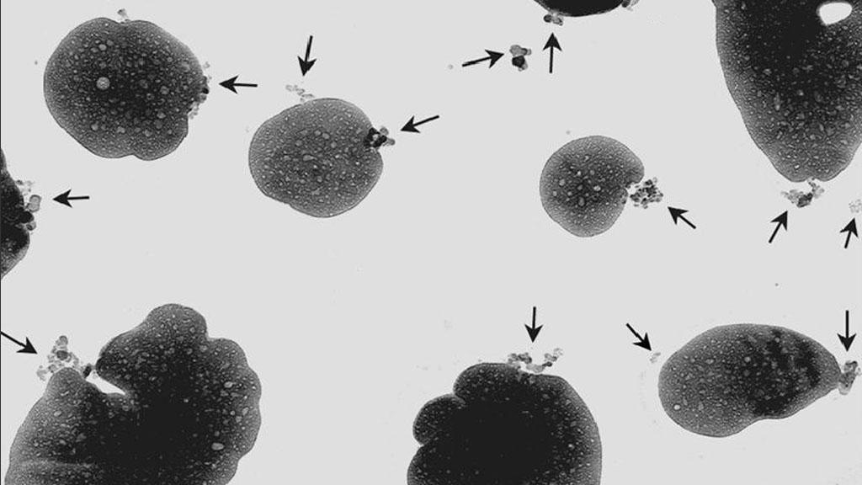

**Figure 8- Chain reaction of soot (arrows) and Sulfate aerosols [2]**

### 3.2.4. Ammonium Nitrate

A chemical reaction between ammonia and nitric oxides forms aerosols called Ammonium nitrate[8] [9]. Ammonia is naturally come from excreta from animals, oceans, and human, while Nitric oxides are come from fossil fuel combustion and lightning[15]. The concentration of ammonium nitrate is high in areas with low temperature and low concentration of sulfate[8]. It causes climate change, and it is a non-greenhouse air pollutant. Ammonium Nitrate can form nitrites in human body, which is a carcinogenic chemical. This may cause chronic fatigue, nausea, and nephritis.[9]  Amine, a derivative of ammonia, reacts with water and nitrogen dioxide to form ammonia, and nitric acid. These chemical compounds chemically react together as ammonium nitrate, which is a solid state aerosol with nitrogen gas and water vapour. Ammonium nitrate is soluble to water vapour, which can be carried into ground with acid rain. [10]

Table 1 summarises the global emissions of gases, which form the aerosols in 2000, and stated potential health effects. The data is referenced from an article ‘global simulations of nitrate and ammonium aerosols and its radiative effects’.

Table 1- Summary of types of aerosols and their effects to health

|  |  |  |  |
| --- | --- | --- | --- |
| Aerosol Type | Source | Global emissions in 2000 (TgN per year) | Health effects |
| Sulfate | Sulfur Dioxide | 99.5[10] | Lung disease[16] |
| Dust | Ocean Minerals  Desert | 77.6[10] | Asthma |
| Black Carbon | Fossil Fuels | 10.5[10] | Respiratory disease |
| Ammonium Nitrate | Nitrate  Ammonia | Nitrate: 41.0 [10]  Ammonia: 53.6[10] | Respiratory disease |

## 3.3. Absorption Spectrum

The electromagnetic energy travels in the atmosphere, and it has a broad spectrum from radio waves to gamma rays. The absorption spectrum is a spectrum used for detecting aerosol thickness in the atmosphere as aerosols absorb or scatter optical wavelengths from the Sun. It can be classified into three categories, which are the UV spectrum (3.3.1), the visible spectrum (3.3.2) and the infrared spectrum (3.3.3). [17] This spectrum is between 100nm to 1mm, as shown in Figure 9. Atmospheric gases such as water vapour, carbon dioxide, ozone and oxygen absorb an amount of solar radiation in specific wavelengths, as shown in Figure 10.

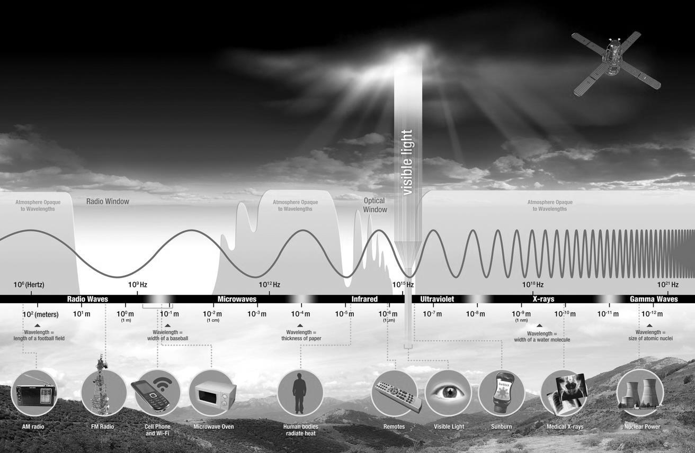

**Figure 9 - Electromagnetic Wave Spectrum Diagram[11]**

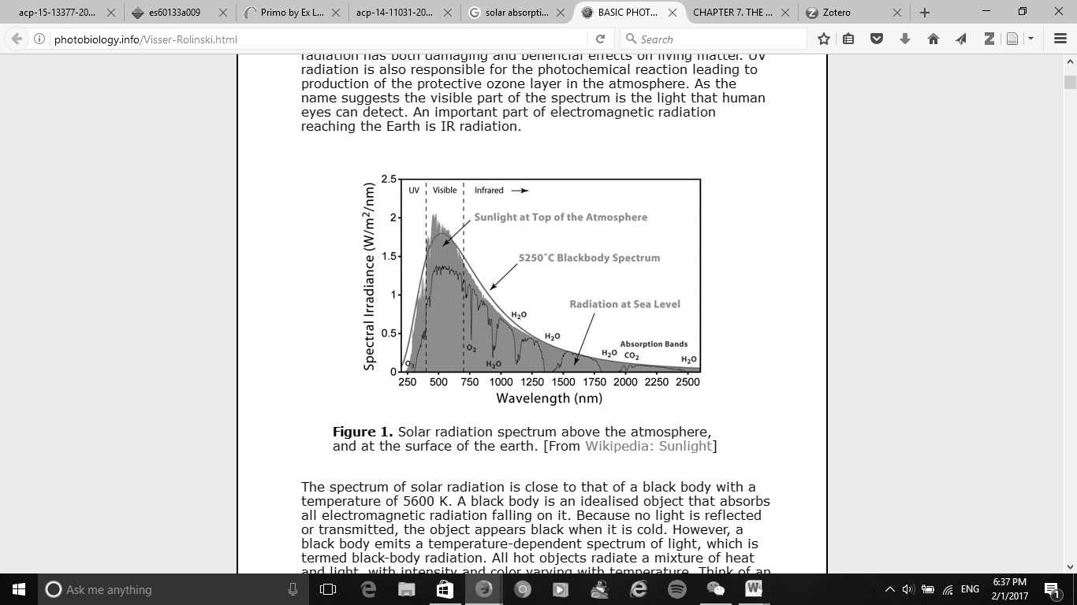

**Figure 10 – Solar Absorption Bands of Atmospheric gases in the atmosphere [12]**

### 3.3.1. UV Spectrum

The ultraviolet spectrum includes wavelengths, which are shorter than visible wavelengths. This includes UV radiation and UV intensity. The wavelengths within this spectrum are between 100nm to 380nm, and is characterised into 3 regions, UV-A (315nm – 380nm), UV-B (280nm -315nm) and UV-C (100nm – 280nm). Ozone layer absorbs a majority of ultraviolet wavelengths, where the radiation at sea level is less than 0.5 W per square metre[18].

### 3.3.2. Visible Spectrum

The visible spectrum is the part of electromagnetic spectrum, which includes wavelengths in visible range. It roughly ranges between 380 nm and 780 nm. These wavelengths are visible from human eyes, and the visible colours are corresponding to specific wavelengths within the visible spectrum. Aerosols Optical Depth (AOD) measurements use wavelengths within visible spectrum to detect the thickness of aerosols in the atmosphere [8][18]

### 3.3.3. Infrared Spectrum

The infrared spectrum includes wavelengths, which are longer than visible wavelengths. It roughly ranges between 700nm to 1mm. IR-A (700nm – 1400nm), IR-B (1400nm – 3000nm) and IR-C (3000nm – 1mm) are three categories within the infrared spectrum. Figure 10 shows that water vapour has strong absorption bands at 940nm, 1100nm, 1380nm in IR-A region. Water vapour also has a relatively weak absorption band at 870nm [18]. Therefore the application of using this spectrum is to perform water vapour measurements where the detection wavelengths are 870nm and 940nm respectively. [17]

## 3.4. Beer-Lambert Law

The sun photometer data requires modeling techniques for better calibration. A modeling method, which is simple for calibration is Beer-Lambert Law [19]. It can determine how much light intensity is absorbed or scattered by aerosols and water vapour in the atmosphere. It is a method of performing Aerosols Optical Depth Measurement, and water vapour measurements [19]. This method is to plot a calibrated data by integrating the voltage taken from the sun photometer and the solar zenith elevation angle. Solar zenith elevation angle is an angle between the sun and its vertical surface. Using elevation angle from the horizontal surface can determine the solar zenith angle as in equation 1.

(Equation 1)

The elevation angle is essential for the sun photometer because it gives the air mass, and the relationship with the voltage data with reference to Beer’s Lambert Law. A GPS positioning sensor gives information about time and location in terms of latitude and longitude. This will give the elevation angle, hour angle (HRA), and declination angle . Therefore it enables with the sun photometer to calibrate data on aerosol optical depth measurements and water vapour measurements[20] [21]. The data will then compute the air mass, which will be the data in the x-axis of the Langley Extrapolation Plot.

(Equation 2)

Therefore, using elevation angle can also determine the air mass referring to equation 3:

(Equation 3)

The elevation angle will be essential for the sun photometer because it will give the air mass. A GPS positioning sensor can give information about time and location in terms of latitude and longitude. This will give the elevation angle, and hence it will enable with the sun photometer to calibrate data on aerosol optical depth measurements and water vapour measurements. The data will then compute the air mass, which will be the data in the x-axis of the Langley Extrapolation Plot in Figure 11. The optical depth of aerosols and other substances is the level of aerosol contents.

(Equation 4)

## 3.5. Langley Extrapolation

The raw data from the sun photometer must be calibrated to show the aerosol optical depth against the air mass with minimal noise and errors. Langley Extrapolation is a method, which is derived from Beer Lambert Law. It calibrates the data by taking the natural logarithm of incoming voltages. The method is named after Samuel P. Langley discovered that the amount of solar energy is linearly dependent on air mass with his researches in early 20th century [19].

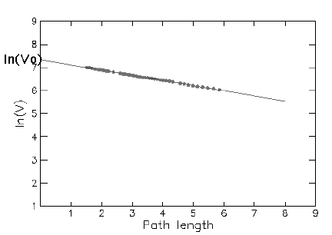

Figure 11 – Langley Extrapolation Plot [22]

This method uses natural logarithm to calibration the results into a linear line, as shown in Figure 1. Taking natural logs from equation 4 gives the Langley extrapolation line in Equation 5.

(Equation 5)

The term can be eliminated through multiple measurements in the same wavelength at different air mass, in other words, in different solar zenith angles. Therefore the slope of this equation is and rearranging the equation 6 gives the optical depth of aerosols.

(Equation 6)

Using equation can give a calibration slope. The calibration constant is the natural log form of , taking exponential form of equation 6 gives equation 7.

(Equation 7)

The advantage of using Langley Extrapolation is the methodology is simple, and it does not require additional instruments for further calibration. However, the disadvantage is the accuracy of the data is depending on the aerosols distribution in the troposphere, and the method assumes that it performs measurement in stable atmospheric conditions[19] [23].

## 3.6. Perez-Dumortier Model

Perez-Dumortier Model is a data calibration method from Langley extrapolation, where it has a statistical filter and data modelling technique.[23] This method can be used in near sea-level location because it filters out any unstable atmospheric conditions by setting clearness sky indexes. The objectives of using this model are 1: to determine the clearness of the sky and 2: the effects of aerosols to air pollution. The advantage of using Perez-Dumortier model is it can calibrate data in near sea-level locations, which means it can filter out excessive data. However, this will require monthly analysis to find out the best-calibrated data.

The Perez Model uses solar irradiance data and solar zenith angle in radians to classify the clearness of the sky with the clearness index ε[23][24]. The solar irradiance data includes global horizontal irradiance, direct normal irradiance and diffuse horizontal irradiance. The clearness index εis defined as in Equation 8.

(Equation 8)

The solar irradiance is measured in , and the distance between the sun photometer and the sun is 1 astronomical unit (1 AU). [25]Therefore, the solar irradiance data can be presented in terms of voltage. The sun photometer will be mounted on a tracking device, which can track the direction of the sun. This means that the voltage data related to solar irradiance will be depending on the properties of the photodiode sensors. Photodiodes and light emitting diodes are sensors that will detect the voltage from the sun, and they have specification on their viewing angle . The viewing angle of sensor is the angle the sensor can detect from incoming light[26]. The full detection beam is at the halfway line between two halves of the viewing angle. It will be the critical factor to determine the diffuse horizontal irradiance and the direct normal irradiance because the voltage data collected from the sensors is the total voltage of the direct horizontal voltage and diffused horizontal voltage. The diffuse horizontal voltage can be calculated from the direct horizontal voltage , and global horizontal voltage , with two diffuse beams at half of the sensors’ viewing angle. It can be done on a clear day without any aerosols. Equation 9 shows the global horizontal voltage and Equation 10 shows the diffuse horizontal voltage

(Equation 9)

(Equation 10)

Rearranging equation 10 in terms of voltage gives:

(Equation 11)

The Dumortier Model uses cloud ratio (CR) and Nebulosity index (NI) to indicate the clearness of the sky[23][4]. Solar elevation angle, air mass, and voltages calculated in Equation 12 and equation 13 are data, which can compute the model. Solar elevation angle and air mass determine the clear sky illuminance , and the Rayleigh scattering coefficient . This gives CR and NI in equation 15 and equation 16 respectively.

(Equation 12)

(Equation 13)

Rearranging the equation 11 and 13 can give the relations between the clearness sky index and the Nebulosity Index by using the ratio between global horizontal voltage and the diffuse horizontal voltage. This concludes that the two indexes are directly proportional to each other.

(Equation 14)

(Equation 15)

The sun photometer can integrate with these models. This can identify the clearness of the sky with conditional statements in software programming. The values of indices determine the clearness of sky in the atmosphere. This determines the level of air pollution and aerosols optical depth in the atmosphere, as described in Table 2.[24]

Table 2 – Clearness Sky index with Perez-Dumortier Model[24]

|  |  |  |  |  |
| --- | --- | --- | --- | --- |
| Clearness Sky index with Perez-Dumortier Model | | | | |
| Value of indices | | Sky Conditions | | Level of pollution |
| Clearness Index ε | Value of NI | Perez Model | Dumortier Model | Processing unit integration |
|  | 0.95 < NI < 1.00 | Clear sky | Blue | Low |
|  | 0.70 < NI < 0.95 | Partly cloudy | Intermediate blue | Medium low |
| 0.20 < NI < 0.70 | Intermediate mean | Medium |
| 0.05 < NI < 0.20 | Intermediate overcast | Medium high |
|  | 0.00 < NI < 0.05 | Cloudy | Overcast | High |

# 4. Feasibility analysis of sun photometers

The objectives of this feasibility analysis are to identify the advantages and disadvantages of the sun photometers used in past experiments, analysing the feasibility of sun photometer in this research, and identify the research opportunities through integrating with radio communications. Sun photometers described in Section 4.1, Section 4.2, Section 4.3, Section 4.4, and Section 4.5 have various features, which made them feasible for past experiments. Table 3 and Table 4 summarise the capabilities and applications of these sun photometers

## 4.1. GLOBE Sun photometer

The GLOBE Sun photometer is a two-channel mobile sun photometer made by David Brooks in Institute of Science Research and Education. It contains a green LED, which detects voltage response at 500nm and a red LED, which detects voltage response at 625nm. The hardware implementation of this sun photometer contains two trans-impedance amplifiers with a toggle switch to select the voltage reading. A 9V battery supplies power to the sun photometer with a toggle switch to activate it. [28] It costs $140 to order this sun photometer [28]. The advantage of using this sun photometer is it is easy to build, and it only contains several components with a digital voltmeter interface. However, it does not provide the full range of detecting aerosols optical depth since it only has two channels to detect the aerosol thickness. [28].

The main difference between GLOBE sun photometer and the sun photometer designed for this researches the number of active channels for aerosol optical depth measurements. There are various aerosol sizes in the atmosphere, and it is better to detect different wavelengths from the sun with more active channels. A display will be mounted into the sun photometer for display multiple measurements at the same time. The advantage of having more active channels is it will enable more wavelength detection and will detect various aerosols at the simultaneously. GLOBE sun photometer only enables detecting one voltage data with selectable toggle switch, whereas the sun photometer designed for this research is capable to detect wavelengths at 440nm, 525nm, 635nm, 870nm, and 940nm. It has 5 detection channels and able to detect the voltage simultaneously. It is also capable for miniaturization, as it is important for integration with radio transceiver modules.

## 4.2. SkyClarity Device

The SkyClarity Device is a mobile sun photometer made by Dr. Andrew Kufel. It contains 5 optical channels, a pressure sensor, and a humidity sensor. The device has a data interface with an application in iPhone platform through an audio jack cable. The application shows the recorded data on each channel. The sensor is tuned through temperature characterisation[29]. There is a magic tape on the case to secure an iPhone on the sun photometer. The advantage of using SkyClarity Device is it eliminates extra LEDs for signal conditioning by using switchable gains through a multiplexer. However, it requires an audio jack cable to interface between the phone and device, which means that an energy harvesting circuit is required to store the input power from the phone in order to supply the device. [30] [31] [32]

The main differences between SkyClarity Device and the sun photometer for this research are the method of power supply and data communications.  SkyClarity device enables both power supply and data communications with a mobile phone through an audio jack cable, whereas solar panels will supply power to the sun photometer in this research. The solar panels will then go through a voltage regulating circuit to supply regulated voltages to the sun photometer. It also has 16-bit ADC with programmable gains, which can give flexibility on adjusting the amplification of the circuit to 5V. The resolution of the instrument is also capable for accurate measurements. The sun photometer designed for this research will also be able to communicate to mobile devices through GSM mobile communications, and the device will be autonomous on data logging the voltages, and able to produce Langley calibration plots.

## 4.3. Sun and Sky Monitoring Station by Radioshack

The Sun and Sky Monitoring Station, also called as Radioshack, is a monitoring station made by Forest Mims. It contains 4 channels, which enables voltage detections at 525nm, 625nm, 816nm, and 940nm.  It also has an adjustable shadow band, a collimator, a compass, and a sun angle and air mass scale. The advantages of using this device are it is convenient to set up the amplification of the channels with the digital readings LCD screen. It also has an adjustable shadow filter to detect the effects of shadowing the sun photometer. However, the disadvantage of using this station is it does not record data simultaneously. This means the user needs to do data logging into the notebook in order to analyse the data. [33] The digital readout can only present an output of one sensor channel through a selectable switch.

The differences between Sun and Sky Monitoring Station by Radioshack and the sun photometer designed for this research are the sun-tracking device, the number of active sensor channels, and the data logging method.  The sun photometer for this research is capable on recording 5 sensors channels, and record them simultaneously. It is capable to be a data logger, where the data can be automatically stored on the SD card and the computer. The detection wavelengths at the sun photometer for this research will be at 440nm, 525nm, 635nm, 870nm, and 940nm.  A tracking device will be mounted with a sun photometer for tracking the path of the sun. This will give the sun angle, and air mass of the device. A computational program will be installed into the tracking device, where it can transfer the air mass data with the sun photometer for logging data into the processing unit. This will enable autonomous data calibration using Langley Extrapolation and Perez Dumoriter Model.

## 4.4. Sun and Sky Monitoring Station by University of Southampton

Miss Zainab Orooq and Miss Mine Ericas make Sun and Sky Monitoring Station from University of Southampton. This device enables user interface through Bluetooth. It has 5 sensor channels, which has detection wavelength at 480nm, 565nm, 768nm, 816nm, and 935nm. The channels have signal conditioning with trans-impedance and instrumentation amplifiers, where they take the difference between the light current and the dark current to obtain the voltage response from the channels. The advantage of using this sensor is the sensor will be simply controlled by the trans-impedance amplifier gain setting. The device is also portable and easy to interface with mobile applications. The disadvantage is there are variations on spectral response between two same photodiodes. Besides, it requires spectral calibration on the photodiodes in order to detect desired spectral wavelengths [34].

The main difference between Sun and Sky Monitoring Station by University of Southampton and the sun photometer used for this research is the architecture of instrumentation amplifier. Sun and Sky Monitoring Station used AD620 dual-rail instrumentation amplifier, which requires both positive 5V supply and negative 5V supply. This means that it requires a dual regulated voltage circuit to supply both voltages towards AD620 instrumentation amplifier.

The sun photometer designed for this research will use ADS1115 Analog-Digital-Converter (ADC) as the instrumentation amplifier. It will be a 16-bit ADC instrumentation amplifier with programmable gain controls, 4 analogue input channels and enables I2C interface to the processing unit. The main advantage of using this instrumentation amplifier will be the resolution of voltage detection, as each step is 1.875mV. The Arduino will also support 4 instrumentation amplifiers with 4 different I2C addresses. A 5-channel sun photometer will fit with 2 ADS1115 instrumentation amplifiers to detect incoming voltage data.

## 4.5. Microtops

Microtops is a handheld sun photometer, which provides aerosol optical thickness measurements for wavelengths at 340, 380, 440, 500, 675, 870, 936, and 1020nm. World Meteorological Organisation recommends five of those wavelengths. The advantages of using Microtops are it provides various detection wavelengths, portable, and has read-only memory. The disadvantages are it is expensive, and consumes a lot of processing space.[35]

The main difference between Microtops and the sun photometer designed in this research is the channels used for aerosols optical depth measurements. The sun photometer designed for this research has 5 channels, whereas Microtops has 8 channels. The advantage of having fewer channels is it saves the processing memory consumption in software programming.

Table 3 – Summary of the feasibility of previous sunphotometers

|  |  |  |
| --- | --- | --- |
| **Sun photometer device** | **Detection wavelengths** | **Advantages** |
| Proposed instrument | * 440nm * 535nm * 635nm * 870nm * 940nm | * 16 bit ADC resolution * Simultaneous voltage response on LCD screen * Able to present pollution level * Capable for Data logging * Calibration is in the direction of the sun |
| GLOBE sun photometer[22] | * 500nm * 625nm | * Switchable Channels * Easy to build |
| SkyClarity Device[24] | * 480nm * 525nm * 565nm * 768nm * 814nm | * Switchable gains with a multiplexer * Elimination of a dark LED for signal conditioning * Portable |
| Sun and sky monitoring station Radioshack [30] | * 620nm * 640nm * 816nm * 940nm | * Adjustable Resistor Gains |
| Sun and Sky Monitoring Station (Zainab Orooq) [31] | * 480nm * 565nm * 768nm * 870nm * 935nm | * Single trans-impedance gain control * Portable |
| Microtops | * 340nm * 380nm * 440nm * 500nm * 675nm * 870nm * 936nm * 1020nm | * Ease of use * Portable * Data logger to ROM (read-only memory) * Various detection wavelengths than other sun photometers |

Table 4 – Comparison among sun photometers

|  |  |  |
| --- | --- | --- |
| **Sun photometer device** | **Disadvantages** | **Used experiments** |
| Sun and Sky Monitoring Station (Zainab Orooq)[34] | * Need solar cell battery * May have different detection wavelength for the dark LED | University of Southampton MSc Project |
| Microtops | * £8000 cost * Expensive * Requires large memory space on the processor | 1999 Sky Type Discrimination in South Dakota[36]  2006 AOT measurements in Mohal-Kullu [37] |
| Proposed instrument | * Expensive * LED requires further calibration | Educational use  PhD Research |
| GLOBE sun photometer[28] | * No full range of wavelength detection | Educational use |
| SkyClarity Device[24] | * Needs an audio-jack wire for power and data interface * Consume phone battery | LED Temperature Characterisation  Edinburgh |
| Sun and sky monitoring station Radioshack [27] | * No longer produced * Needs manual data logging | Educational Use |

# 5. Sun photometer Prototype Design

Sun photometer is an instrument for detecting aerosol and water vapour content. The objectives of designing a sun photometer for this research are 1: to ensure that it is able to perform aerosol optical depth measurements at 440nm, 525nm, and 635nm, and 2: perform water vapour measurements at 870nm and 940nm. This chapter will discuss the requirements of achieving the objectives, the research challenges, and preliminary results and discussion.

## 5.1. Requirements for designing a sun photometer prototype

A sun photometer requires photodiodes or LEDs to act as sensors for detecting voltage in experiments such as aerosol optical depth measurements and water vapour measurements. Building a sensor circuit with a trans-impedance amplifier, and an instrumentation amplifier has done this. However, it requires the LEDs or photodiodes at 440nm, 525nm, 635nm, 870nm, and 940nm. This means that choosing LEDs and photodiodes is the main requirement for designing a sun photometer prototype, as they will determine the values of the feedback resistors, and feedback capacitors in the sensor.

The challenge for achieving this requirement is the LEDs and photodiodes have different spectral responses even if they have the same wavelength in the emission spectrum. The detection spectrum of these LEDs and photodiodes is depending on their detection properties, and their voltage responses.

It also requires feedback resistors and feedback capacitors to have low tolerance with reference to temperature change, as they can change the voltages detected from the sensors. This is depending on the prototype architecture, and the temperature isolation between the sun photometer and radio transceiver. This can be done by using a temperature chamber to identify the characteristics of feedback resistors and feedback capacitors under a range of temperature change.

It has to be capable to detect atmospheric pollution in real world situations. This requires a tracking device to mount with the sun photometer in order for the sun photometer to point towards the sun. The tracking device requires a positioning sensor for GPS positioning, as GPS positioning enables water vapour validation. This validation will then compute with the data logger in the sun photometer to present the detect voltages, and the aerosols content.

The sun photometer is capable to apply in several potential applications such as lab-based measurements on particulate matters, and aerosol optical depth measurements in real world situations. This can be done with a chamber for lab-based measurements on particulate matters, and placing collimators to prevent stray lights entering into the sensor.

## 5.2. Research challenges for designing a sun photometer

This section describes the research challenges for designing a sun photometer. Field work locations, and LED characteristics are the main challenges for designing a sun photometer, as these challenges will determine the selection of electronic components, sensors, and the mechanical design of the sun photometer.

### 5.2.1. Field work locations

Aerosols are diverse in terms of size and distribution. They vary in different season, and are depending on both natural and man-made events. Spatial and Temporal Landscapes can affect the results. A journal article from Makiko Nakata [38] analysed the spatial and temporal variations in Eastern Osaka, where clearly the aerosols distribution in spatial landscapes is more concentrated than that in temporal landscapes [38].

Sun photometer records burst data [39]. They have delays per recording, and are weak for radio transmission. The accuracy of recorded data is depending on the location where the data has been recorded. This means that the altitude, and climate can vary the calibration constant [40]Various weather conditions can vary data collection from the sun photometer and the radio frequency used in radio communications. Data given from the previous sun photometer recordings are past data, which can give prediction on air pollution and geographical activity, but not actual situations. Present sun photometer data can give the actual situation at the time, but weather conditions can vary the result.

The location must have plenty of sunlight and steady climate in order to calibrate the best spectral response from the sensor in outdoor area. There will be a need to deploy testing prototypes to laboratories with plenty of sunlight to perform real measurements in outdoor areas. Spectrophotometer gives the most accurate spectral response but the chosen components must be verified in outdoor areas.

### 5.2.2. LED characteristics

Light Emitting Diodes (LEDs) have aging effect, and absorption may be varied after a period of time. This is because LEDs are semiconductors, which are made with Silicon or Germanium Arsenide. They have periods of lifetime and electron activity.[41] [42] Sensitivity of the sun photometer will be depending on the aging effect of electronic components. The feasibility of the sun photometer will be depending on the temperature inside the prototype. This will become significant if the sun photometer is integrated with the radio transceiver because the radio transceiver will transmit heat and will heat up the prototype.

The spectral responses of the LEDs and photodiode sensors require calibration with a spectrophotometer or optical filter kits. The optical filter kits have narrow wavelength bandwidths, which mean the sensors have a more accurate result for calibration, while the spectrophotometer provides a range of wavelengths from 200 – 1000nm. Both methods are essential to find the best spectral response of the sensors. Some LEDs and photodiode sensors will be chosen for detecting wavelengths at 440nm, 535nm, 635nm, 870nm, and 940nm after these calibrations.

## 5.3. Sun photometer prototyping methods

A 5V regulated voltage supply can supply the sun photometer sensor, where this regulated supply can come from solar panels with transformers, rectifier and a voltage regulator. The operational amplifiers MAX9637 and ADS1115 will enable single power supply. The sun photometer prototype will enable selectable pins for inserting resistors, feedback capacitor and LEDs. This enables data calibration and obtaining spectral response from the LEDs.  A surface mount prototype will be the final prototype for the sun photometer as it has chosen LEDs for detecting aerosols optical thickness. A processing unit Arduino Mega 2560 enables data interface with high-resolution data as they have 32-bit processor on the board, and high flash memory. It also includes SDA, SCK interface to external ADC chips for collecting data in higher resolution. A 16-bit ADC1115 integrated circuit will be used to interface between the sensor and the processing unit.

The instrumentation will allow GSM communications with mobile phones, and radio communications with a transceiver. This will provide instant communication data to radio receivers and database distribution in mobile devices. The radio communications will be including software-defined radio, where data is converted to audio/FSK transmission. A radio transceiver will then multiply the frequency from the data into transmission frequencies, which fits to amateur radio license conditions.

The programming code of the sun photometer will enable basic Langley extrapolation method for calibrating data. This will provide simple data interface with sensor and radio transceiver, and will reduce memory consumption on the board-processing unit. The data will then be imported to a database in a computer for statistical filtering and further calibration. Perez-Dumortier model will perform a more accurate data calibration for monthly analysis on aerosols distribution.

The sun photometer will include digital interface with Liquid Crystal Display (LCD) Monitor and a Multicolour LED. LCD monitor and a LED will indicate the level of pollution with voltage data. This will notify the level of pollution based on live data.

## 5.4. Basic tests

### 5.4.1. Spectral Measurements

Spectral response measurement is an experiment, which is used for detecting spectral wavelength response from the LEDs. The principle of performing this measurement is to scatter a light beam source into different wavelengths with a prism or filter, where the LEDs detect the light intensity of the scattered beam.

The trans-impedance amplifier detects the current input from the scattered beam, and converts the current to voltage. The instrumentation amplifier then amplifies the voltage output from the trans-impedance amplifier, and sends the amplified voltage to Arduino for logging voltage data into a SD card.

Using optical filters can determine the spectral wavelength response at specific wavelengths. They act as filters to filter excessive wavelength from the light source to enter the sensor. The optical filters have different colours, which indicate that they filter wavelengths within the visible spectrum. This method can also perform at different light sources such as the sun, a mobile device, or a lamp.

The optical filters have the peak transmission wavelengths at 420, 440, 500, 530, 565, 580, 610, 680, 700, 720, 730, and 740nm, which are within the visible range 380 – 780nm. The LEDs have different responses from these wavelengths, and they are depending on the intensity of the light source, and the distance between the source and the sensor. This method uses a phone flashlight application as a light source, and the gain setting is set as 1 in the instrumentation amplifier. The optical filter is placed above the source, where the LED sensor touches for increasing its sensitivity on spectral response. The method to prevent stray light getting in around the edges is to place the LED in contact with the filter, and directly points to the main beam of the light source, as shown in Figure 12.

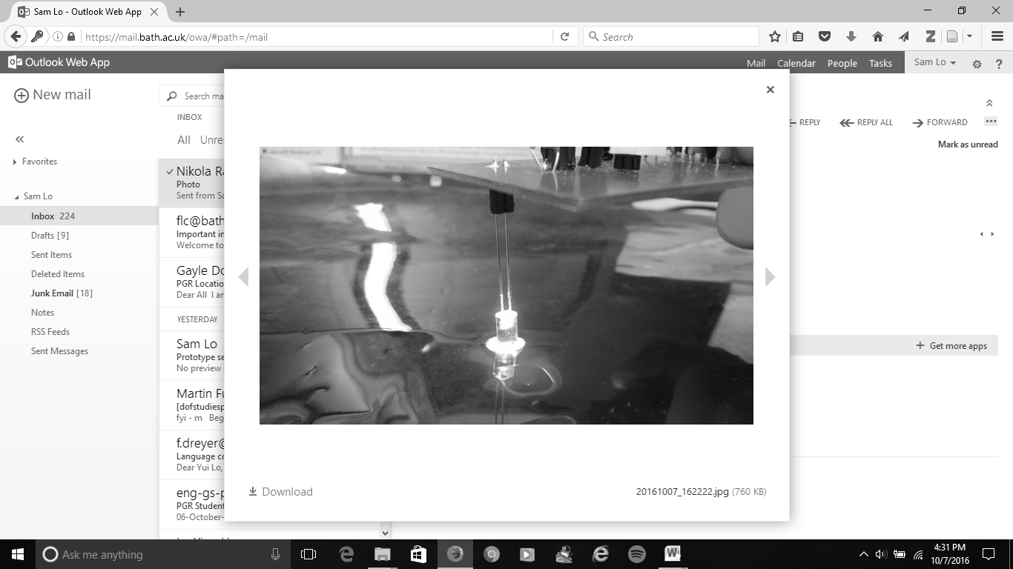

Figure 12 - Experimental setup of sun photometer prototype with phone light source and optical filter

## 5.5. Results and discussion – Optical Filters

Preliminary results can be used to find LEDs suitable for specific wavelengths, and using optical filters and spectrophotometer can obtain these results. The advantages of using optical filters are it can perform outdoor measurements, and it enables to change light source. For example, using a phone flashlight app with optical filters can provide spectral response within specific wavelengths. The outdoor measurements are based on collecting data from the sun. The disadvantages of using optical filters are the results are not accurate, and the response is subjected to the direction where the sensor points. It is also vulnerable to outdoor weather, and therefore casing is needed to ensure that the sensor is weatherproof.  The results from outdoor measurements are also subjected to the direction of the sensor towards the sun, and the diffused lights from the sun.

Using optical filters can detect the LED response in specific wavelengths. The specific wavelengths are based on the maximum transmitted wavelength on each filter. The LEDs, which emits within in the visible range has a better spectral response than the infrared LEDs. Table 5 details the results of using optical filters.

Table 5– Optical Filter spectral measurements results

|  |  |  |  |  |
| --- | --- | --- | --- | --- |
| **Wavelength** | **1045478 yellow led** | **1045476 Green LED** | **2112109 590nm led** | **Thorlabs 1050nm infrared LED** |
| 420 | 0.189 | 0.337 | 1.274 | 0.16 |
| 440 | 0.627 | 1.192 | 2.096 | 0.16 |
| 500 | 0.8916 | 1.395 | 2.218 | 0.25 |
| 530 | 1.0718 | 1.1717 | 2.212 | 0.243 |
| 565 | 3.693 | 3.212 | 1.931 | 0.271 |
| 580 | 3.6314 | 2.232 | 1.981 | 0.1919 |
| 610 | 1.232 | 0.691 | 2.183 | 0.2616 |
| 680 | 2.234 | 1.2211 | 2.0316 | 0.1411 |
| 700 | 1.3719 | 0.589 | 2.0517 | 0.3122 |
| 720 | 0.187 | 0.6418 | 0.583 | 0.346 |
| 730 | 0.4618 | 0.234 | 1.206 | 0.3 |
| 740 | 0.562 | 0.183 | 0.5716 | 0.182 |

The LEDs, which emits within visible range, has a wide spectral response, and has more noise within the measurements. Figure 16 shows that there is a very wide spectral response in 590nm yellow LED. It has recorded at around 2V at from 440nm to 700nm, and a response of more than 1V at 730nm.



**Figure 13 - Green LED Optical Filter Spectral Response**



Figure 14 - Yellow LED Optical Filter Spectral response

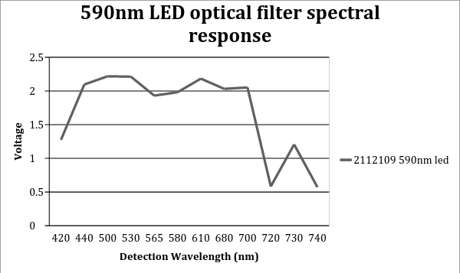

**Figure 15: 590nm LED Optical Filter Spectral Response**

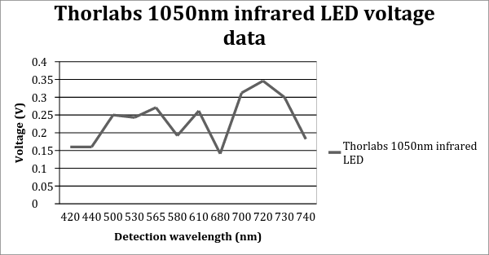

Figure 16 - 1050nm Infrared LED Optical Filter Spectral Response

Figure 16 shows that the infrared LED does not have the same sensitivity as the visible LEDs within the visible range, where the maximum response within the spectrum range is 0.35V at 720nm. However, it also shows that noise also occurs as the infrared LED has uneven spectral response from 440nm to 740nm.

Figure 13, Figure 14, Figure 15 and Figure 16 show the preliminary results of the LED spectral responses. The optical filters used for these measurements have different light permittivity, and various wavelengths can pass through the filter. Therefore, the measurements in Figure 13, Figure 14, Figure 15 and Figure 16 can only show the peak response of the LEDs at each peak transmission wavelengths per filter. The results will require calibration to find the peak detection wavelength from the LEDs.

# 6. Future Research Work

## 6.1. Plan for the rest of PhD

The plan for the rest of PhD is mainly focused on data interface with radio communication, integration with GPS Positioning Sensor, and to validate data against GPS water vapour. This includes system integration, and journal publications. The sun photometer will include a LCD monitor and a status LED to present the pollution level using sky clearness indexes.

### 6.1.1. System integration

The sun photometer will require system integration with GPS positioning sensor to validate the data against the direction of the solar elevation angle. The hardware will require circuit stability test and system integration for achieving better calibration results. The objectives of stabilising the circuit are 1: to minimise the noise within the circuit design, and 2: to ensure that the design is robust. The stability of the circuit will be important for accurate measurements and calibration. The circuit will include a trans-impedance amplifier and an instrumentation amplifier. The preliminary results from last year shows that the voltage response from the circuits can go to a maximum of 5V, however, there are no indications on its stability. Therefore the circuits will require an oscilloscope to identify the noise from the circuit tests. The oscilloscope will display the comparison when sensor receives ambient lights, and light source in full intensity.

The expected results will be the circuit is stable with less noise and able to detect spectral response from both the spectrometer and outdoor environments. The outcomes from circuit stability testing will be graphical results of voltage against irradiance and detection wavelength. The spectral response of the sun photometer sensor will be capable to detect wavelengths as mentioned in Section 5. The sun photometer will be capable to integrate with GPS positioning sensor to identify the pollution level through voltage measurements, location and time.

### 6.1.2. Journal Publications

There are plenty of opportunities to make journal publications during the rest of the PhD research. Researches on the novel design of atmospheric instrumentation and research applications are 2 main directions to make journal publications in this PhD research. The main research is on the novelty of the atmospheric instrumentation, where it is focused on hardware and software interface and data calibration. Previous sun photometers and atmospheric sensors show that they can perform measurements. However, it requires integration to implement radio communications into the design. Journal publications include research applications. This includes monitoring on air pollution and aerosols distribution in different landscapes and time. It is also an analysis of the effect of natural disasters. There will be two potential papers for publications this year. The papers will be for calibrating the instrument throughout the season in Bath and monitor the water vapour contents in the atmosphere.

The first publication for the research is ‘Calibration of the sun photometer over the UK’. The objective of this publication is to monitor the air pollution and aerosols distribution in the UK, and to investigate a method of developing a new sun photometer.  This will be useful for monitoring the pollution contents in the UK.

The objective of this paper is 1: to calibrate a sun photometer to the local atmosphere by measuring atmospheric aerosol over a period of a year. The location is Bath University. The calibration will take into account the season and elevation of the sun (hence, the path through the atmosphere.) for nominal days throughout the year. Initial calibration of the sun photometer will take place in the laboratory. Further comparison will be made with Perez-Dumortier model.  A sun photometer is an instrument, which is capable to measure the aerosol contents in the UK. The approach to calibrate the sun photometer is taking measurements with the sun photometer in Bath for 12 months, and taking similar measurements with an established sun photometer called Microtops in Oxford and Southampton at the same period as those in Bath. It will take 6 nominal days per each month for measurements.

This will give the comparison of measurements with established sun photometers for data calibration. The instrument will also calibrate with Langley Extrapolation for live data and Perez-Dumortier Model for Monthly analysis. It is likely to conclude that the new instrument is able to calibrate a more accurate data for measuring pollution in the atmosphere, where the results can fully show the voltage data.

### 6.1.3. Validate against GPS Water vapour

Water vapour measurement will also be a research application for the sun photometer. The climate in the UK is varied by the water vapour contents, and dependent on the aerosol activity in the atmosphere. The climate in Bath is temperate and it has lots of rainfalls.

The objective of this paper is 1: to calibrate a sun photometer to the local atmosphere by measuring water vapour content over a period of a year. The location is Bath University. The calibration will take into account the season and elevation of the sun (hence, the path through the atmosphere.) for nominal days throughout the year. Initial calibration of the sun photometer will take place in the laboratory. GPS positioning with tracking device will identify the location where water vapour measurements take place. These data can integrate with voltage measurements from the sun photometer sensor to give analysis on how voltage response changes in different seasons and in different locations with reference to Beer-Lambert’s Law and Langley Extrapolation. Further comparison will be made with Perez-Dumortier model.

The plan for doing water vapour measurements is to investigate the GPS tracking device and the method to mount it with a sun photometer sensor. The investigation of GPS positioning will begin in February 2017. This will then be integrating with sun photometer sensor for water vapour measurements and validation. The plan will last 12 months, which is from February 2017 to February 2018.

The initial start of the measurement will be best to start in the sunrise time, and this is varied by the season and the location where the measurement takes place. Bath will be the place where the measurements will be taken with the sun photometer.

The integration method between the GPS Positioning Sensor and the sun photometer is to use the latitude, longitude and altitude data from the GPS positioning sensor to integrate with the voltage data collected from the sun photometer. The sun photometer will collect voltage data with reference to its detection wavelength, where the data from the GPS positioning sensor will be used to compute the solar zenith angle of the sun photometer and the air mass on the actual location through using HRA. These sets of data will then be computed in parallel to give the voltage data against the air mass. Existing sun photometers like Microtops will be also used for measurements in Oxford and Southampton for doing the same measurements. The objective of using existing sun photometers is to compare the data validity with the sun photometer in Bath. These data will also be used for comparison between different cities. The sun photometer will be able to present the location of the measurements, the voltage data, and the water vapour concentration. This will give essential information on how water vapour contents affect the aerosol activity. Theoretical prediction has been made to predict the solar elevation angle and sky clearness indexes of the location where measurements will take place, details of predicting the indexes are in Appendix 1.

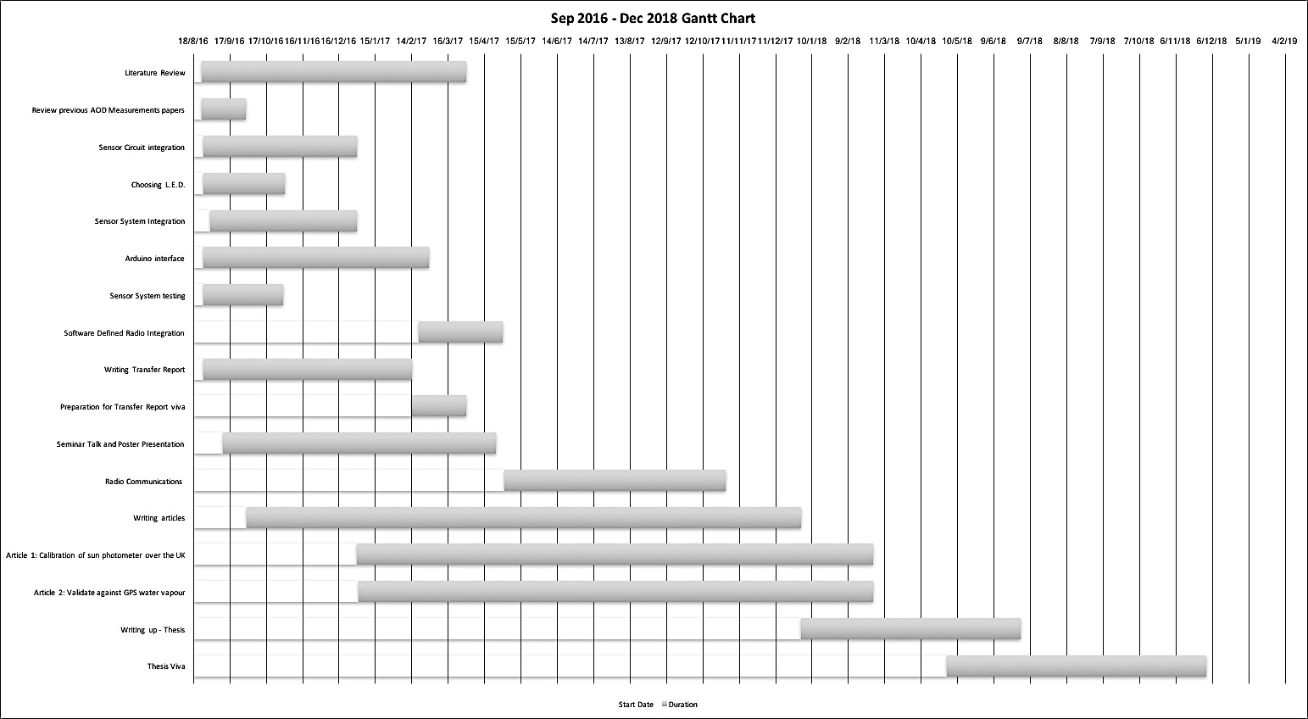

Figure 17 – Gantt Chart

# 7. References

[1] R. Chattopadhyay, *Green Tribology, Green Surface Engineering, and Global Warming*. ASM International, 2014.

[2] J. G. Titus and K. E. Anderson, *Coastal sensitivity to sea-level rise: a focus on the mid-Atlantic region*, vol. 4. Government Printing Office, 2009.

[3] Guy P., John J., and Geoffrey S., ‘Aerosols and Clouds’, in *Atmosperic Chemistry and Global Change*, 117-136: Oxford University Press, 2014.

[4] Jedol Dayou, Jackson Hian Wui Chang, and Justin Sentian, ‘Introduction’, in *Ground-Based Aerosol Optical Depth Measurement Using Sunphotometers*, Springer.

[5] K. . Whitby, R. . Husar, and B. Y. . Liu, ‘The aerosol size distribution of Los Angeles smog’, *J. Colloid Interface Sci.*, vol. 39, no. 1, pp. 177–204, Apr. 1972.

[6] B. Allen, ‘Atmospheric Aerosols: What Are They, and Why Are They So Important?’, *NASA*, 06-Apr-2015. [Online]. Available: http://www.nasa.gov/centers/langley/news/factsheets/Aerosols.html. [Accessed: 18-Jul-2016].

[7] British Lung Foundation, ‘Briefing: Air Pollution and the Nation’s Lung health .pdf’. .

[8] S. Lim, M. Lee, S.-W. Kim, S.-C. Yoon, G. Lee, and Y. J. Lee, ‘Absorption and scattering properties of organic carbon versus sulfate dominant aerosols at Gosan climate observatory in Northeast Asia’, *Atmospheric Chem. Phys.*, vol. 14, no. 15, pp. 7781–7793, Aug. 2014.

[9] Kenneth A. McGee, Michael P. Doukas, Richard Kessler, and Terrence M. Gerlach, ‘Impact of Volcanic Gases’. [Online]. Available: https://pubs.usgs.gov/of/1997/of97-262/of97-262.html. [Accessed: 18-Jan-2017].

[10] Y. Ji, H. Wang, G. Li, and T. An, ‘Theoretical investigation on the role of mineral dust aerosol in atmospheric reaction: A case of the heterogeneous reaction of formaldehyde with NO2 onto SiO2 dust surface’, *Atmos. Environ.*, vol. 103, pp. 207–214, Feb. 2015.

[11] N. Mahowald *et al.*, ‘The size distribution of desert dust aerosols and its impact on the Earth system’, *Aeolian Res.*, vol. 15, pp. 53–71, Dec. 2014.

[12] H. Chen, J. G. Navea, M. A. Young, and V. H. Grassian, ‘Heterogeneous Photochemistry of Trace Atmospheric Gases with Components of Mineral Dust Aerosol’, *J. Phys. Chem. A*, vol. 115, no. 4, pp. 490–499, Feb. 2011.

[13] L. Zhou, W. Wang, M. Ge, and S. Tong, ‘Heterogeneous uptake of gaseous hydrogen peroxide on mineral dust’, *J. Environ. Sci.*, vol. 40, pp. 44–50, Feb. 2016.

[14] ‘NASA Viz: Black Carbon: A Global Presence’. [Online]. Available: https://svs.gsfc.nasa.gov/3844. [Accessed: 30-Sep-2016].

[15] G. Bedford and J. H. Thomas, ‘Reaction between ammonia and nitrogen dioxide’. [Online]. Available: http://pubs.rsc.org.ezproxy1.bath.ac.uk/en/content/articlepdf/1972/f1/f19726802163. [Accessed: 26-Jul-2016].

[16] S. E. Bauer, D. Koch, N. Unger, S. M. Metzger, D. T. Shindell, and D. G. Streets, ‘Nitrate aerosols today and in 2030: a global simulation including aerosols and tropospheric ozone’, *Atmospheric Chem. Phys.*, vol. 7, no. 19, pp. 5043–5059, 2007.

[17] G. Butcher, United States, and National Aeronautics and Space Administration, *Tour of the electromagnetic spectrum*. 2016.

[18] K. N. Liou, ‘Absorption and Scattering of Solar Radiation in the Atmosphere’, in *Introduction of Atmospheric Radiation*, 2nd ed., Elsevier, pp. 65–116.

[19] Jedol Dayou, Jackson Hian Wui Chang, and Justin Sentian, ‘Ground-based Aerosol Optical Depth Measurements’, in *Ground-Based Aerosol Optical Depth Measurements Using Sunphotometers*, Springer, pp. 9–29.

[20] I. Reda and A. Andreas, ‘Solar position algorithm for solar radiation applications’, *Sol. Energy*, vol. 76, no. 5, pp. 577–589, 2004.

[21] M. Blanco-Muriel, D. C. Alarcón-Padilla, T. López-Moratalla, and M. Lara-Coira, ‘Computing the solar vector’, *Sol. Energy*, vol. 70, no. 5, pp. 431–441, 2001.

[22] J. A. Augustine, J. J. Michalsky, and G. B. Hodges, ‘P4. 35 AN AEROSOL OPTICAL DEPTH PRODUCT FOR NOAA’S SURFRAD NETWORK’.

[23] Jedol Dayou, Jackson Hian Wui Chang, and Justin Sentian, ‘Chapter 3 - Near-Sea-Level Langley Calibration Algorithm’, in *Ground-based Aerosol Optical Depth Measurement*, pp. 31–37.

[24] R. Perez, P. Ineichen, and R. Seals, ‘Modelling daylight availability and irradiance components from direct and global irradiance’.

[25] R. E. Bird and C. Riordan, ‘Simple Solar Spectral Model for Direct and Diffuse Irradiance on Horizontal and Tilted Planes at the Earth’s Surface for Cloudless Atmospheres’, *J. Clim. Appl. Meteorol.*, vol. 25, no. 1, pp. 87–97, Jan. 1986.

[26] Vishay, ‘High Efficiency LED in Ø 3 mm Tinted Diffused Package.pdf’. .

[27] Djamila H. Ming, ‘Estimation of exterior vertical daylight for the humid tropic of Kota Kinabula city in Easy Malaysia’.

[28] ‘Building a GLOBE Sun Photometer’. [Online]. Available: https://www.cs.drexel.edu/~dbrooks/globe/construction.htm. [Accessed: 31-May-2016].

[29] Jedrzej Kufel, ‘SkyClarity_LEDs_TemperatureCharacterisation’. [Online]. Available: https://dl.dropboxusercontent.com/content_link/WvYzncxggXO4oy0ylBkV3AJgPh0SS8dyeZTo2osFf780MO894QZgWTN9VxPAug2n/file?dl=1. [Accessed: 21-Jul-2016].

[30] Jedrzej Kufel, ‘SkyClarity_TestJig_Manual’. [Online]. Available: https://dl.dropboxusercontent.com/content_link/jPRfpdXFiE5prBGve9HIYqk1UX1wSIkQAock2D1uraX1gBNscdgLtgcp8nL4xPaq/file?dl=1. [Accessed: 21-Jul-2016].

[31] Jedrzej Kufel, ‘SkyClarity_Summary’. [Online]. Available: https://dl.dropboxusercontent.com/content_link/gC4Wi59ozALQ0iDAPKBFXlrmcRQL6l3FAV4CIs0kP9peXQAO4Vl6TOEQTs2nTirq/file?dl=1. [Accessed: 21-Jul-2016].

[32] Jedrzej Kufel, ‘SkyClarity_ProtoDemonstrator(Firmware)’. [Online]. Available: https://dl.dropboxusercontent.com/content_link/0cNmSeQhlDG24cudP4zbG14463v6oebnNojOzYGOLzPnjL6CBnub0JhzwGHakxLK/file?dl=1. [Accessed: 21-Jul-2016].

[33] ‘Forrest M. Mims III’. [Online]. Available: http://www.forrestmims.org/. [Accessed: 23-Sep-2016].

[34] Z. Orooq, ‘MSc Project Dissertation Sun and Sky Monitoring Station (Sensor Side)’, Jun. 2012.

[35] O. Monitor, ‘MICROTOPS II’, 2001.

[36] T. P. DeFelice and B. K. Wylie, ‘Sky type discrimination using a ground-based sun photometer’, *Atmospheric Res.*, vol. 59, pp. 313–329, 2001.

[37] J. C. Kuniyal *et al.*, ‘Aerosol optical depths at Mohal-Kullu in the northwestern Indian Himalayan high altitude station during ICARB’, *J. Earth Syst. Sci.*, vol. 118, no. 1, pp. 41–48, 2009.

[38] M. Nakata, I. Sano, S. Mukai, and B. Holben, ‘Spatial and Temporal Variations of Atmospheric Aerosol in Osaka’, *Atmosphere*, vol. 4, no. 2, pp. 157–168, May 2013.

[39] C. Toledano *et al.*, ‘Aerosol properties of the Eyjafjallajökull ash derived from sun photometer and satellite observations over the Iberian Peninsula’, *Atmos. Environ.*, vol. 48, pp. 22–32, Mar. 2012.

[40] J. G. Cerqueira, J. H. Fernandez, J. J. Hoelzemann, N. M. P. Leme, and C. T. Sousa, ‘Langley method applied in study of aerosol optical depth in the Brazilian semiarid region using 500, 670 and 870nm bands for sun photometer calibration’, *Adv. Space Res.*, vol. 54, no. 8, pp. 1530–1543, Oct. 2014.

[41] OSRAM Opto Semiconductors, ‘Reliability and lifetime of LEDs.pdf’. Dec-2013.

[42] M. Ott and others, ‘Capabilities and reliability of LEDs and laser diodes’, *Intern. NASA Parts Packag. Publ.*, 1996.

# 8. Appendix 1 - Theoretical Prediction of solar elevation angle

## 8.1. Solar Elevation Angle Positioning

The solar Elevation Angle is critical for measuring aerosol content in the direction of the sun. It is depending on time, time zone, season, latitude and longitude. The location is Bath University with latitude of 51.2432 degrees and longitude of -2.35363 degrees. The time zone is +GMT 0 with an additional daylight saving hour from April to October. There are 4 distinct seasons in Bath throughout a year, which is also a factor that changes the solar elevation angle. [20]

Figure 1 is a comparison of the solar elevation angle between today, Spring Equinox, Autumn Equinox, Summer Solstice and Winter Solstice. It shows that the solar elevation angle is depending on the season. The maximum solar elevation angle at noon on the summer solstice is above 60 degrees, whereas that in the winter solstice is below 20 degrees. The days of the equinoxes have same elevation angle during noon, but have different sunrise and sunset hours.

### 

Figure 18 – Comparison of Solar Elevation Angle during the year

## 8.2. Theoretical Prediction of clearness indexes

A theoretical prediction has been made to predict the relationship between two indexes with a change of the solar elevation angle. The objective is to find the difference after a period of time. Time is a factor, which can change the solar elevation angle. The predictions in Figure 3, Figure 4 and Figure 5 uses solar elevation angles to compare the indexes. The original data, which is in blue lines, uses a solar elevation of 45 degrees, whereas the red lines are the data where the solar elevation angle is 5 degrees less than the original data. Nebulosity Index cannot be greater or equal to 1, however, Perez index allows to go above 4.50. Therefore, the prediction uses the Nebulosity Index as the main axis to predict the voltage ratio of the voltage collected from the sun photometer. The assumption of this prediction is the diffuse voltage is fixed by the sensor viewing angle.

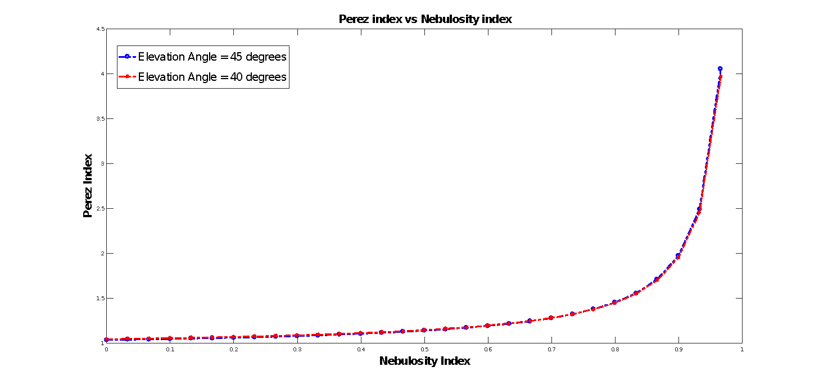

**Figure 19 - Perez Index vs Nebulosity Index**

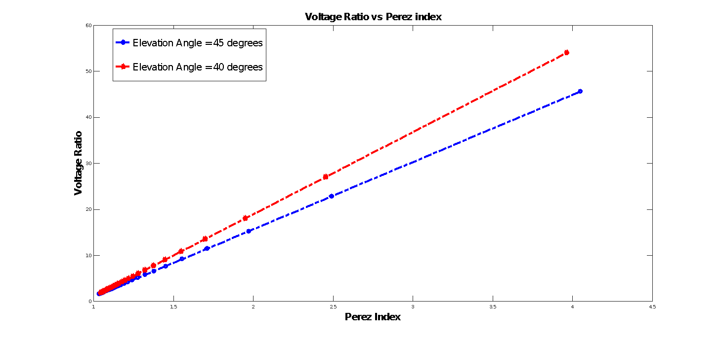

Figure 20 – Voltage Ratio vs Perez Index

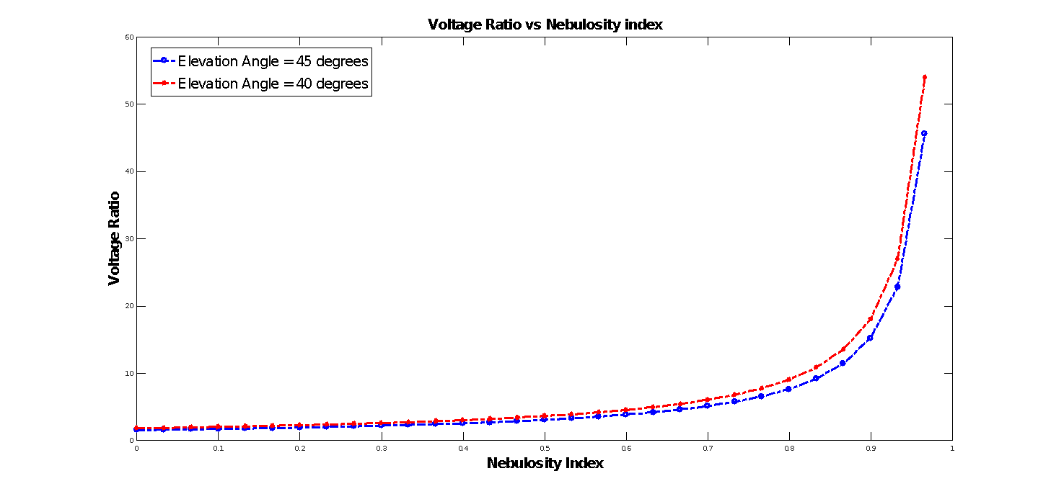

Figure 21– Voltage Ratio vs Nebulosity Index

The location and time will change the nebulosity index if the voltage ratio remains unchanged. The voltage ratio can predict the clearness of the sky and the water vapour content, the water vapour content is expected to be less dense when the voltage ratio increases. Nebulosity Index is directly proportional to Perez Index. The rate of change in Perez index from Nebulosity Index is depending on the solar elevation angle and the collected voltage.

Figure 21 shows that the data with 40 degrees requires a higher voltage ratio to reach the same Nebulosity index as that with 45 degrees. The difference is getting bigger when the Nebulosity Index reaches 0.7. The slope in Figure 4 is also depending on the solar elevation angles. It shows that the voltage ratio at 40 degrees has to be higher than those at 45 degrees, and the difference also becomes significant when the Perez index is greater than 1.5.